BUSAN 302 group project report

BUSAN 302
Group Project Report

Predicting Video Game Sales Based on Critic and User Review Scores

Dataset chosen: VideoGames.csv

Team
Joshua Walton - UPI: jwal741
Lily Liang - UPI: mlia383
Sri Kadali - UPI: skad446
Jeevesh Concisom - UPI: jcon125

Table of Contents

Executive Summary 3
Introduction 4
Descriptive Statistics 4
Data preprocessing 7
Handling Missing Values 7
Feature Selection 8
Feature Scaling 8
Model Results 9
Train-Test Split and model training 9
Model Evaluation 10
Conclusion 10
Business implication 10
Limitation 11
Ethics 12
Final Summary 12
Reference 13

Executive Summary
This report responds to the following research question: To what extent can critic and user review scores predict the global success of a video game? Based on the VideoGames.csv database and under the supervised learning approach, we employed a linear regression model to test if critic and user review scores can be effective predictors of global sales performance. Following extensive data cleaning, removal of missing values, and normalisation of features, the model was fitted on an 80:20 train-test split. The final model had just two predictors, Critic_Score and User_Score, with an R² of 0.117 and RMSE of 1.53, which meant that merely 11.7% of global sales' variance could be attributed to review scores alone. Though the model finds a weak yet existing correlation between reviews and sales, the findings highlight that other variables, platform, genre, marketing, and release timing, will more likely be greater contributors to sales. The business implications are that review scores need to be used as secondary metrics and not primary predictors. Limitations like exclusion of categorical variables, depending on reviewer scores subjectively, and simplicity of linear regression model are recognised, as well as ethical concerns regarding fairness, data bias, and responsible usage. Finally, the research underscores the limitations of relying on review scores only for commercial prediction in the video game sector and strengthens the case for more accurate, multi-dimensional data approaches to support improved decision-making in game development, marketing, and platform planning.

Introduction
The video game sector is a multi-billion-dollar industry that encompasses a wide range of platforms, genres, and audiences. Against the background of the rapid advancements in technology and fierce competition, success factors in video games are of primary concern to developers, publishers, and marketers. From arcade machines and cartridge consoles since the late 20th century, the industry has moved to networks and multiplayer environments. Amidst all the competition in the marketplace, the ability to make game sales forecasts in terms of measurable factors means a head advantage not only in product development as well as marketing.

This report investigates patterns and correlations within the VideoGames.csv dataset, which includes 6,250 entries of video game data across multiple platforms and years.
The dataset contains key features such as:
- Name: Title of the video game
- Platform: Gaming platform (e.g., PS2, Xbox)
- Year_of_Release: Year the game was released
- Genre: Game genre (e.g., Action, Sports)
- Sales Data: Regional sales in millions across North America (NA), Europe (EU), Japan (JP), and Other markets
- Global_Sales: Combined worldwide sales in millions
- Critic_Score and User_Score: Ratings from professional critics and users

The central question this project seeks to answer is: “To what extent can critic and user review scores predict the global success of a video game?”

This question guides our analytic framework and model selection. We take a supervised learning approach with Global_Sales as the target variable. Our model is focused on Critic_Score and User_Score despite other features to explore the influence of perceived quality on commercial performance. Among the various machine learning algorithms for its interpretability and ability to predict continuous results. This model allows us to examine the degree to which external review scores may explain a game’s commercial success.

The rest of this report presents a structured study. It begins with descriptive statistics and progresses through data preprocessing, model development, and evaluation. The study aims to demonstrate how machine learning can uncover insights from video game data, thereby assisting the industry in making more informed decisions.

Descriptive Statistics
The following key numerical variables were included in our initial exploration of the dataset:
- NA_Sales, EU_Sales, JP_Sales, Other_Sales: These represent game sales in millions of units across North America, Europe, Japan, and other regions, respectively.
- Global_Sales: The total worldwide sales in millions, derived from summing regional sales.
- Critic_Score: A numerical rating out of 100 provided by professional reviewers.
- User_Score: A normalised score out of 10 reflecting user ratings.

The summary statistics table below summarises the distribution of each numerical feature:
Variable | Mean | Std Dev | Min | 25% | 50% | 75% | Max
NA_Sales | 0.401 | 1.000 | 0.000 | 0.060 | 0.150 | 0.390 | 41.36
EU_Sales | 0.243 | 0.715 | 0.000 | 0.020 | 0.060 | 0.210 | 28.96
JP_Sales | 0.067 | 0.299 | 0.000 | 0.000 | 0.000 | 0.010 | 6.50
Other_Sales | 0.085 | 0.281 | 0.000 | 0.010 | 0.020 | 0.070 | 10.57
Global_Sales | 0.796 | 2.043 | 0.010 | 0.110 | 0.290 | 0.750 | 82.53
Critic_Score | 69.93 | 13.99 | 13.00 | 61.00 | 72.00 | 80.00 | 98.00
User_Score | 7.14 | 1.46 | 0.50 | 6.40 | 7.50 | 8.20 | 9.60

Table 1. Summary Statistics Table
These statistics show that, while most video games sell in low numbers, there is a minority that sell in high numbers, evidenced by high standard deviations and maximum values. North America is the strongest market, followed by Europe, while Japan and other countries or areas have relatively lower sales volumes. Although regional sales dominate overall totals, our approach purposely excludes these to avoid redundancy. Instead, we look at the consistency of review scores. Critic and user ratings are generally well-aligned, with both centred in the mid-to-high range and showing moderate variability, making them promising candidates for modelling commercial success.
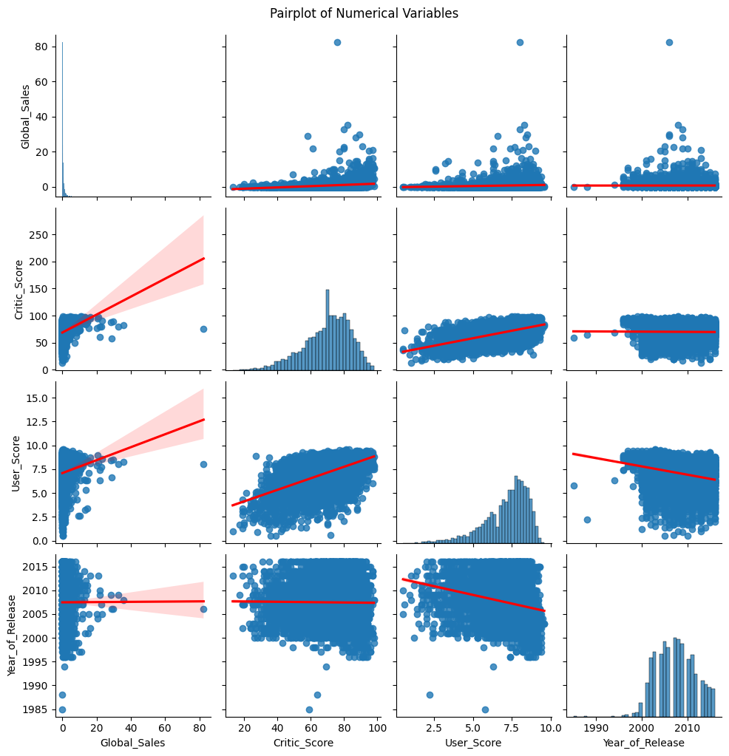
Figure 2. Pairplot of Global_sales, Critic_Score, User_score, and Year_of_Release.

The pair plot illustrates moderate positive correlation between global sales and critic and user ratings, with the trend for critic scores looking slightly more pronounced. User ratings are more dispersed, reflecting variability in public opinion, while a moderate correlation with critic scores suggests general alignment with some differences. Release year shows a cluster of games developed between 2005 and 2015, reflecting a peak in game development; however, this feature was not included in the modelling. There are no strong non-linear trends, which supports the use of linear regression.

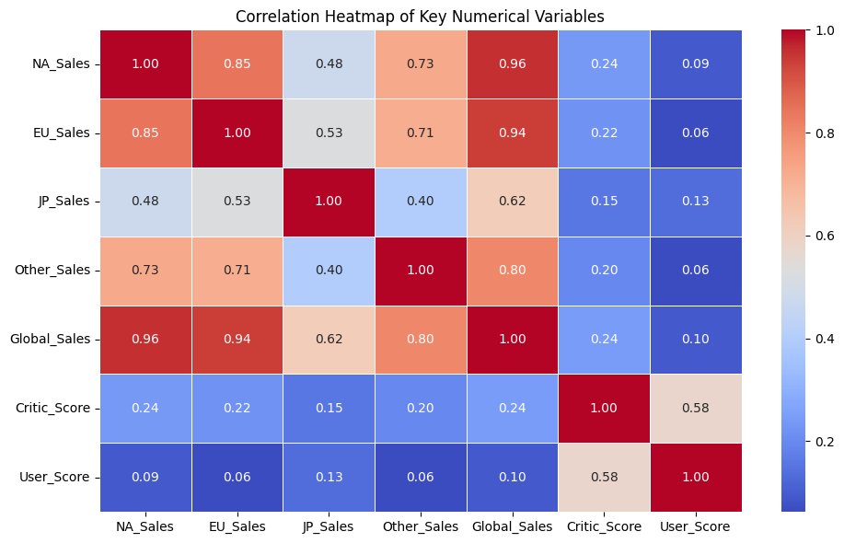
Figure 3. Correlation Heatmap of Key Numeric Variables.

The correlation heatmap shows that sales in various regions are strongly correlated with overall sales, particularly NA_Sales (0.94) and EU_Sales (0.90), indicating that the sales of these regions weigh significantly towards the overall performance. However, to avoid duplication and leakage, regional sales were omitted from the model. Critic_Score and User_Score are positively correlated (0.57), suggesting overall agreement among professional and public reviews. They are loosely correlated with Global_Sales (0.24 and 0.10), suggesting that more highly reviewed games sell more, but reviews alone do not strongly dictate sales outcomes.

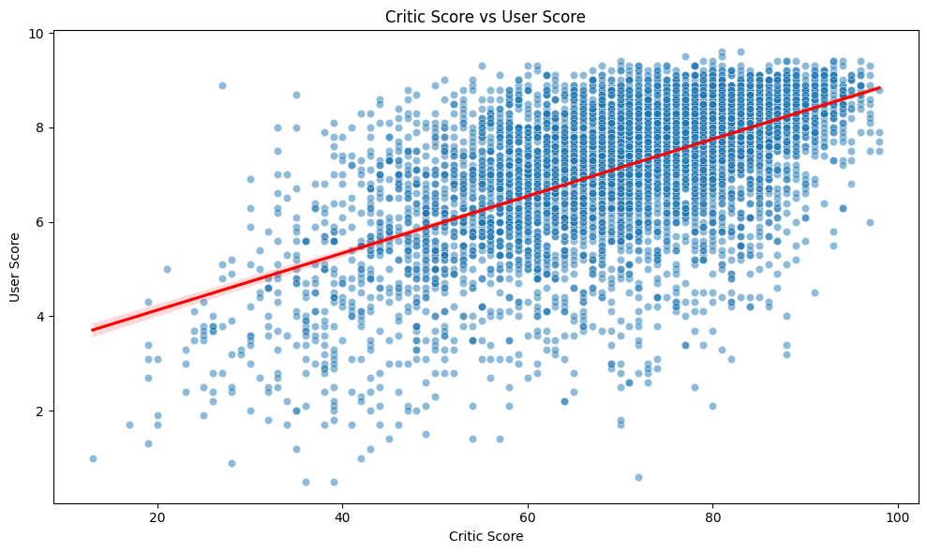
Figure 3. Scatter plot of correlation between Critic vs User Score.

There is positive linear association, with highly rated games among critics being highly rated among users as well. There is wide scatter, especially within the 60–90 critic score range, showing variation in public opinion. This suggests that games liked by critics aren’t always liked by gamers, and vice versa. The red line of regression shows the overall upward direction, but the variation along with it shows that there are probably other factors, genre, platform, or popularity of franchise, for instance, that could be affecting user opinion. While these could explain more variation, this project focuses solely on review scores to evaluate their direct relationship with global sales.

Data preprocessing
Data preprocessing was necessary to ensure the data is clean, standardised, and prepared for application in predictive models. This process included handling missing values, feature selection and standardising numerical attributes. All of them are required to improve the performance as well as stability of the model, especially for regression problems that are sensitive to scale differences and extreme values.

Handling Missing Values
The data analysis indicated that there were missing values in many numeric columns, i.e., NA_Sales, EU_Sales, JP_Sales, Other_Sales, Critic_Score, User_Score, and Global_Sales. Although the final model consisted only of Critic_Score, User_Score, and Global_Sales, regional sales were included in the initial investigation. Therefore, missing values in these columns were addressed in the data cleansing process.

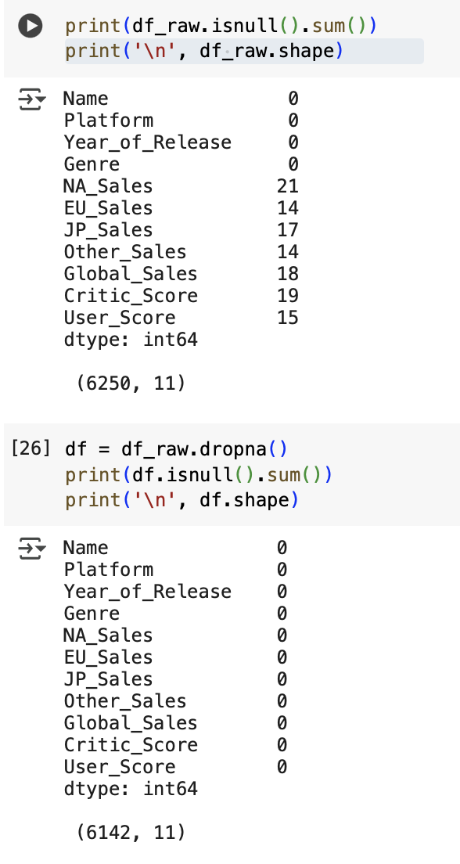
Rows containing missing values in any of these key numeric columns were removed using the .dropna() method. This decision was supported by the fact that all other columns, including Name, Platform, Year_of_Release, and Genre, were complete and unaffected. A total of 108 rows (just over 1.7% of the dataset) were removed, resulting in 6,142 complete entries. This minimal reduction was not expected to negatively influence the model's generalizability.
Figure 4. Missing value summary and dataset size before and after cleaning.

Feature Selection
The model includes only two quantitative variables: Critic_Score and User_Score. These were selected because they reflect how a game is rated by both professional critics and users. Based on review scores alone, we look into their influence on a game’s commercial success. Other numerical variables, such as NA_Sales, EU_Sales, JP_Sales, and Other_Sales, were considered during exploration but excluded to avoid data leakage. Global_Sales is the sum of these regional values, and their inclusion would have artificially lifted model performance without helping predictive power. Platform, Genre, and Name were dropped due to high cardinality and difficulty encoding into linear models. Their inclusion would have decreased model interpretability and added to model complexity. Year_of_Release was tested but had low correlation to global sales and did not make any contribution to predictive effectiveness and was therefore dropped.

Feature Scaling
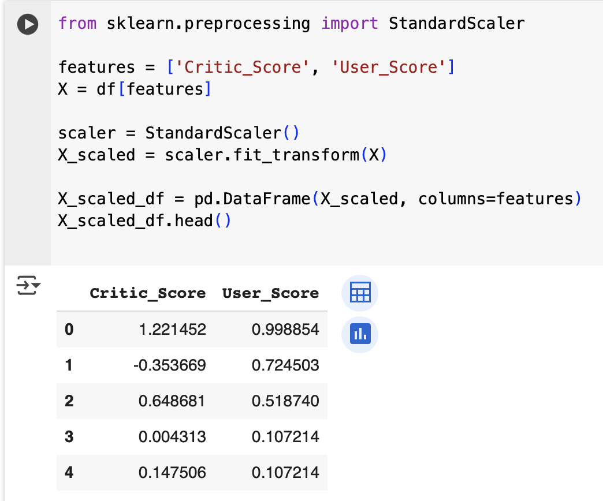
The two chosen input features, Critic_Score and User_Score, are of different scales: critic scores are typically in the 0–100 range, while user scores are in the 0–10 range. To ensure the features contribute equally to the regression model and the model’s coefficients are not skewed by scale differences, we standardised with StandardScaler() from the scikit-learn library. The process normalised the features to a mean of zero and standard deviation of one. Standardisation allows for more interpretable model results, enables comparison of coefficient meanings on the same terms, and prevents one feature from dominating based on its value range.
Figure 5. Standardisation applied to Critic_Score and User_Score using StandardScaler().

Model Results
A linear regression model was built to estimate global sales using critic and user review scores. The model was trained and tested in Python, with performance evaluated using standard metrics such as R-squared and RMSE.

Train-Test Split and model training
The dataset was split into training and testing sets using an 80:20 ratio. This allowed the model to learn from most of the data while evaluating its performance on a holdout set that it had not seen during training.
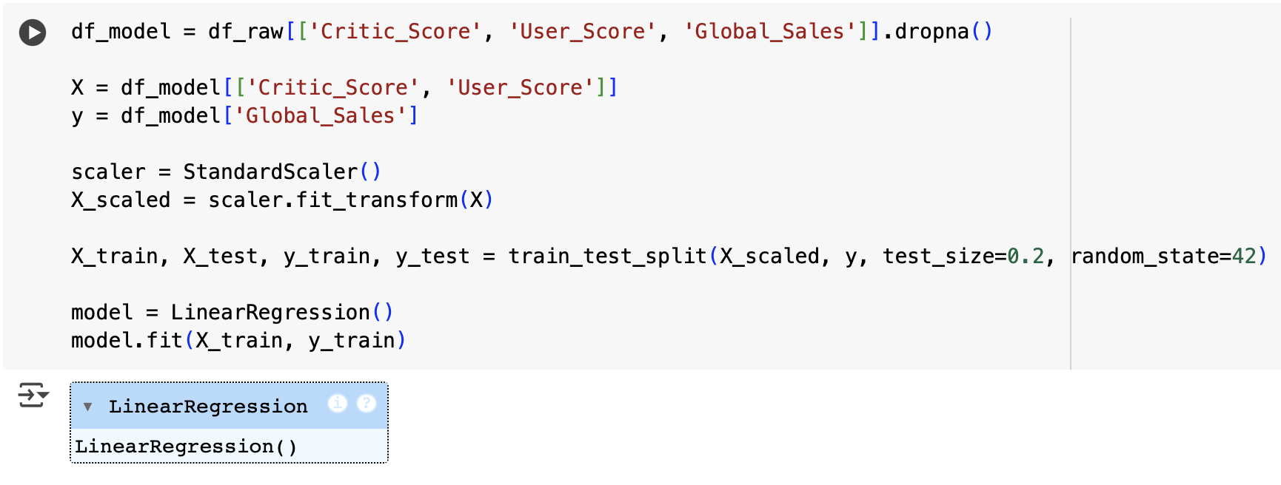
Figure 7. Code used for Train-Test Split and Linear Regression Model Training

Model Evaluation
After training the linear regression model, we evaluated its performance on the test set using two standard metrics:
- R-squared (R²): Measures how well the model explains the variance in global sales.
- Root Mean Squared Error (RMSE): Measures the average prediction error in the same units as the target variable.
This evaluation helps assess how well the model generalises to unseen data and the usefulness of the selected features.
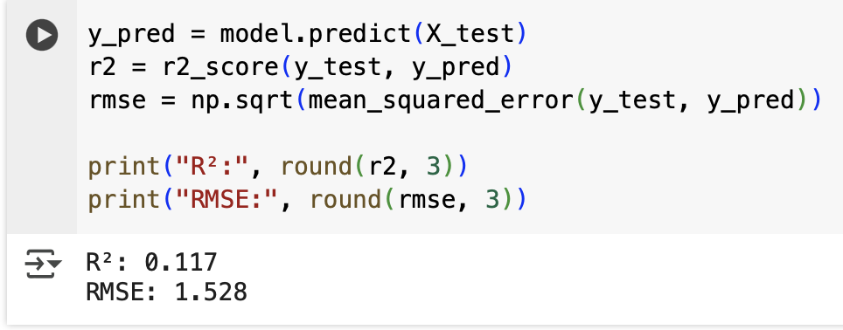
Figure 8. Evaluation of the linear regression model using R² and RMSE on the test set.

On the test set, the model achieved the following performance:
- R²: 0.117
- RMSE: 1.53
On the test dataset, R² = 0.117 and RMSE = 1.53. This indicates that about 11.7% of global sales variability is explained based entirely on the scores from reviews (Critic_Score and User_Score). This does show predictive capability, but indicates that much of the variation that happens in sales performance isn't explained by these two characteristics separately.

RMSE of 1.53 million units substantiates this restriction; predictions from the model are off by more than the median global sales in the data (which is less than 1 million per year). This is to say that while improved review scores are related to improved commercial success, the model is not capable of making exact numerical predictions of a game's commercial achievement.

Conclusion

Business implication
The findings of this study indicate that both users' and critics' scores are factors that contribute to video game purchasess but are not good single predictors. Since model explanations account for a mere 11.7% of variance for worldwide sales, it is evident that there are several factors that contribute to whether a game becomes a commercial success or not.

For game developers and publishers, it would indicate that using review scores as a predictor of how successful games perform could not be effective. A broader methodology that takes into account several factors such as advertising campaigns, platform, release date, and franchise power would be called for. Studies have confirmed that platform choice has a significant role to play when assessing how games succeed beyond their homelands (Babb et al., 2013). Moreover, advances in digital distribution and growth of subscription-based models have shifted the spotlight from traditional sales numbers to player engagement and retention. Studies indicate that engagement numbers, such as active players and playtime, are becoming critical metrics to gauge a game's success (Van Crombrugge & Stremersch, 2025).

From these observations, developers should broaden their definition of how performance is measured beyond review scores. Adding Engagement levels, market trends, and platform dynamics to the equation gives a more comprehensive view of a game’s potential for performance, which can be translated into wiser development and marketing choices.

Limitation
While this study successfully applied a linear regression model to predict global sales based on critics and user review scores, several limitations likely contributed to the model’s weak performance.

First, the most important problem is the limited number of features that are utilised. Critic_Score and User_Score are indicators of perceived game quality, but they don't capture all the elements that contribute to commercial success. Marketing costs, franchise popularity (e.g., FIFA vs. an independent game), pre-release hype, price strategy, and release timing (e.g., holiday season vs. off-season) are some of the many factors that impact global sales. The model only covers a limited aspect of what influences a game's market performance if such aspects are not included (Marchand & Hennig-Thurau, 2013).

Secondly, categorical attributes such as Platform and Genre were intentionally excluded to maintain model simplicity and avoid complex encoding of high-cardinality features. This likely took away from the model's predictive power. Platforms differed from their base audience, popularity, and regional dominance; that is, games from Nintendo play stronger in Japan, and Xbox play relatively stronger in North America. The same holds for genres such as Action and Shooter, outpacing Puzzle or Adventure games in Western markets. These are empirically justified through existing literature, which has proved platform and genre to be significant influencers of sales outcomes and are good predictors when included in model frameworks (Song, 2024). These attributes, included through steps such as one-hot or target encoding, would have contributed to greater accuracy but would have meant more involved preprocessing.

Third, while regional sales columns (NA_Sales, EU_Sales, JP_Sales, Other_Sales) had to be excluded to avoid data leakage (they sum to Global_Sales), that design choice resulted in extremely sparse numeric input to the model. The regression had not nearly the variety of features that are needed to characterise a variable of such high variance, like sales, which varies from less than 0.01 million to over 80 million units sold.

Lastly, a simple linear model had limitations. Such a model assumes that the association between input and output would be straightforward and linear, which would not necessarily be true in such cases. In real-world situations, association between reviews and overseas sales would be more subtle, and many different factors would be impacting each other. Linear regression would be unable to capture those subtle trends, and hence such a model could have left out significant associations. Flexible models like random forests or decision trees might be able to capture such trends, but they would necessarily be less interpretable.

Ethics
While our analyses draw upon publicly available information for making predictions about global buying behavior, there are ethical concerns about how these models would be interpreted or applied. One significant consideration is that review scores are subject to significant subjectivity and can occasionally be influenced by manipulation, including coordinated review bombing. This is where a surge of negative reviews is posted with the aim of manipulating public perception, which can or cannot reflect the quality of the game. Such behavior can lead to biased or unreliable information being afforded significance by predictive models, much to the disadvantage of minority-supported or niche games (Cantone et al., 2024).

Another problem is the data is biased towards historically popular titles and franchises in Western and Japanese markets. It under-represents newer formats such as mobile games, indie games, or non-English language markets (e.g., China, Southeast Asia, Latin America). This under-representation can lead to the model generating predictions that do not generalise well to today's globalised gaming environment, restricting fairness and inclusivity to conclusions made from analysis.

It is also worth noting that predictive models like ours are best used as supportive tools rather than decision-makers. They are helpful for trend detection and strategy direction, but not a substitute for human judgment or adaptable to the complex, innovative, and ever-evolving environment of the games market. Transparency, honesty about model limitations, and avoidance of overreliance upon what it provides are all important to ethical use.

Final Summary
In conclusion, this project examined how well critic and user review scores can forecast worldwide video game sales. The results indicate that although such scores do have a weak but detectable association with sales results, they fall far short of being sufficient as sole predictors. This supports the requirement for more extensive models that utilise a larger number of attributes in a way that more precise and useful predictions can be made in the video game sector.

Reference
Babb, J., Terry, N., & Dana, K. (2013). The impact of platform on global video game sales. International Business & Economics Research Journal (IBER), 12(10), 1273. https://doi.org/10.19030/iber.v12i10.8136

Cantone, G. G., Tomaselli, V., & Mazzeo, V. (2024). Review bombing: ideology-driven polarisation in online ratings: The case study of The Last of Us (part II). Quality & Quantity. https://doi.org/10.1007/s11135-024-01981-z

Marchand, A., & Hennig-Thurau, T. (2013). Value creation in the video game industry: industry economics, consumer benefits, and research opportunities. Journal of Interactive Marketing, 27(3), 141–157. https://doi.org/10.1016/j.intmar.2013.05.001

Song, M. (2024). Research on Influencing Factors of Video Game Sales using Binary Logistic Regression. Highlights in Science Engineering and Technology, 107, 65–70. https://doi.org/10.54097/dz307b45

Van Crombrugge, M., & Stremersch, S. (2025). Engagement in platform markets: A (video) game changer? Journal of the Academy of Marketing Science. https://doi.org/10.1007/s11747-025-01089-2

